**Kaitlyn Dean**

**Task 2 – Wireshark Log Dissector**

**SOFTWARE DESIGN SPECIFICATION SUBMISSION TEMPLATE**

1.0 Introduction

This program takes in a file name and returns the total number of frames, the number of HTTP frames, the number of DNS frames, the number of TCP frames, the number of UDP frames, the number of ARP frames, and the number of three-way handshakes.

1.1 Goals and objectives

I hope to make the program not break if the file does not exist but instead gives the user to re-enter a file name if they wanted.

1.2 Statement of scope

The program takes in the file name and outputs the dissected information into a table format. It then, asks the user whether they want to dissect another file or not.

1.3 Software context

Getting information through the Wireshark GUI can be a bit tedious and take more time. This command line program returns the information immediately.

1.4 Major constraints

It can only take in pcap files so other files will be rejected by the program.

2.0 Data design

The program is written in the language tshark and written inside of a batch file.

3.0 Architectural and component-level design

There is an input and a choice option that determines if the user wants to enter in another file or not. The choice with either redirect to the input again or close the program.

3.2.2 Component n interface description.

A file name is inputted then the output is created then, you can input another file name or close the program.

4.1 Description of the user interface

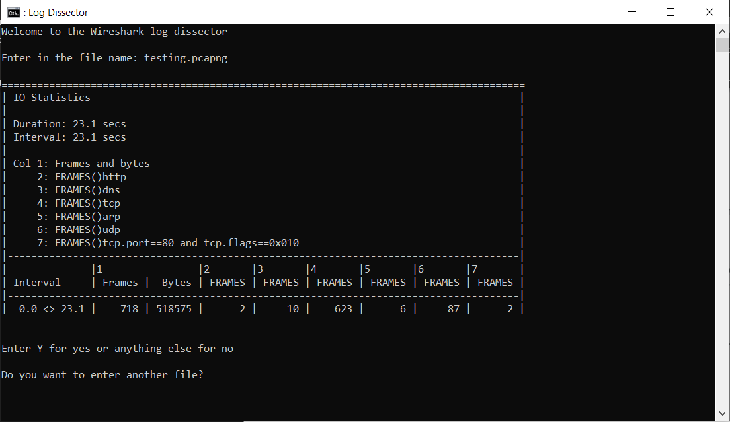

4.1.1 Screen images



6.0 Testing Issues

Testing different files to see which would work and which would fail. Ensure program can work past the failed files and does not just crash.

6.2 Expected software response

The program will accept the pcapng files and allow the user to dissect more than one file if they wanted. Program does not crash and outputs the correct results.

7.0 Deliverable

A command line program is given to output total packet counts on certain filters efficiently.

7.3 Deliverable and Deployment

Switch to the directory where the program is downloaded into and start the batch file, input the file name.

New Features

* Exports the Flow Graph into a .txt file.
* Exports the Conversations into a .txt file.
* Exports the Packet List Pain into a .csv file.